1.MODEL COMPARISIONS

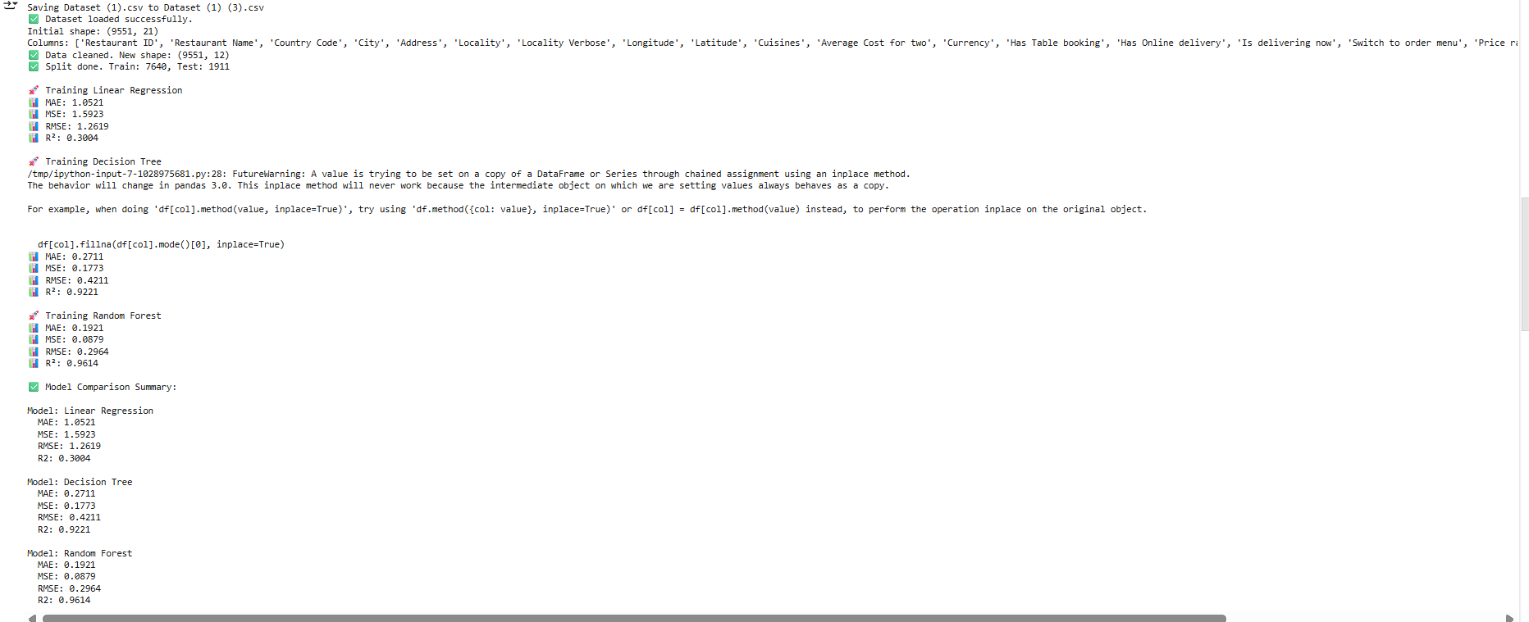

2.GRAPHICAL REPRESENTATION

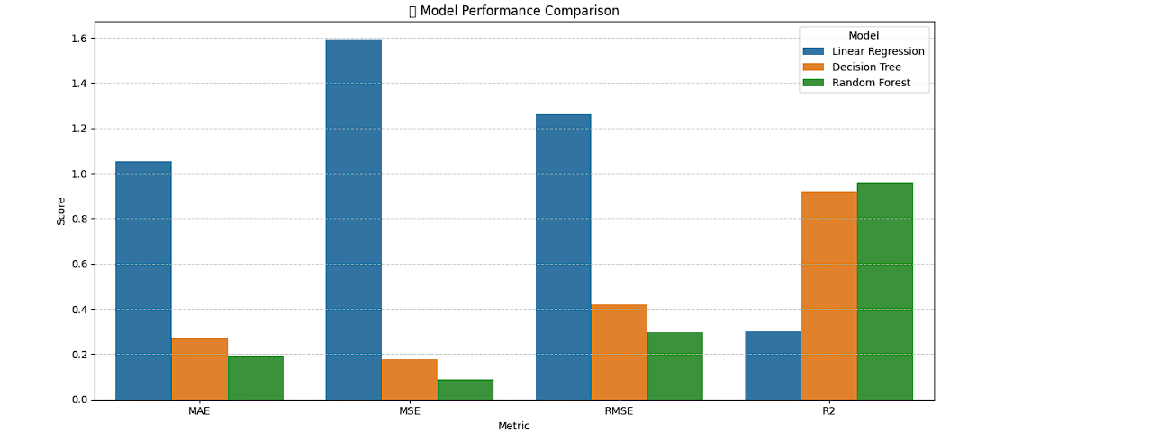

3.TOP FEATURE IMPORTANCES WITH RANDOM FOREST

